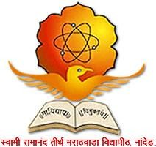

Swami Ramanand Teerth Marathwada University, Nanded- 431606
Internal Quality Assurance Cell (IQAC)
Activity Report

Name of the School / Section: School of Media Studies, SRTM University, Nanded
Activity title:
Swami Ramanand Teerth Marathwada University Nanded and
FTII Film and Television Institute of India, Pune
Basics of Film Making
06 to 10 October 2025
Date: 06 to 10 October 2025
Main Theme: “Basics of Film Making”

- Objective of the activity:
School of Media Studies is a premiere institute in Marathwada for the subjects of Electronic Media. The school provides specialization in film production. With the advances in the field of electronic media and smartphones the restrictions of equipment is no more. Good quality films can be produced on smartphones. The aim of this activity was to introduce the film making through smartphone.

- Beneficiaries of the activity:
- Any filmmaker, student who is aspiring to produce films using Smartphone.

- Numbers of participants: 27
- Registration Fees Collected from Participants: Rs.1,35,000/-
- Details of experts invited for activity:

Mr. Ritesh Taksande,
Course Director,
FTII - Film and Television Institute of India, Pune

- Brief summary of how the activity was conducted:
The activity was planned with theory and practice sessions. Small groups were formed to demonstrate the skils they learn and how to avoid simple mistakes. Few short films were screened too.
- Outcome of activity:
Film making concepts were explained and demonstrated to the participants. 6 groups were formed and assignments were given to produce films using minimum equipment. Participants enthusiastically performed the film production activities. 6 short films were produced in the course and they were screened too.

- Photo gallery (with captions)
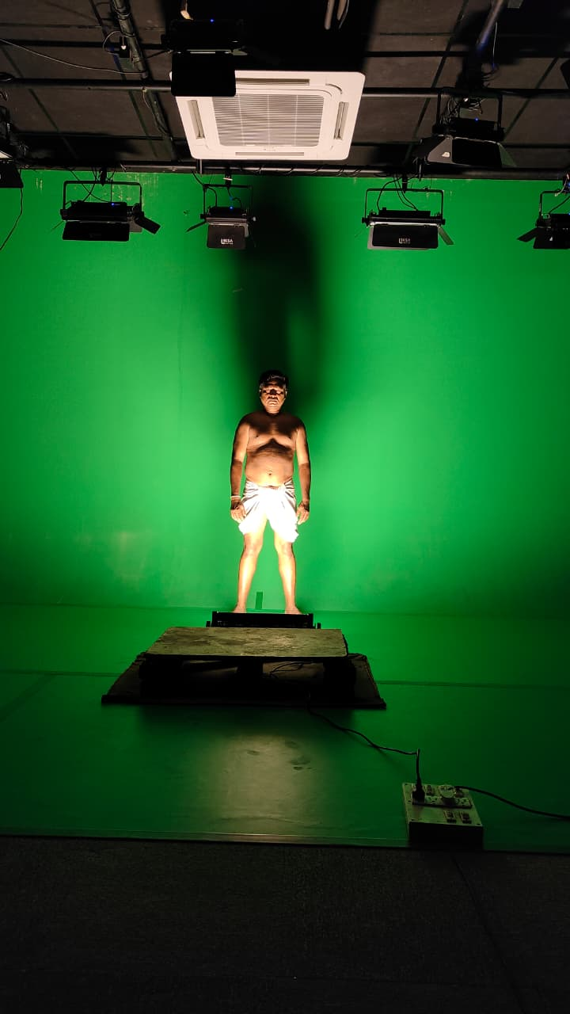
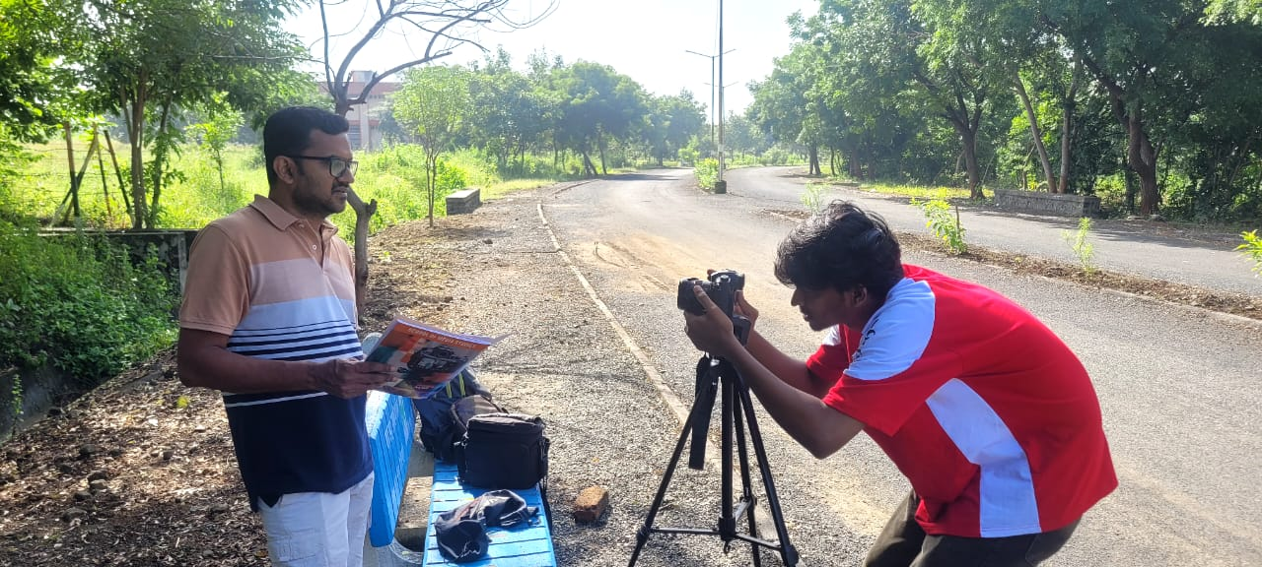
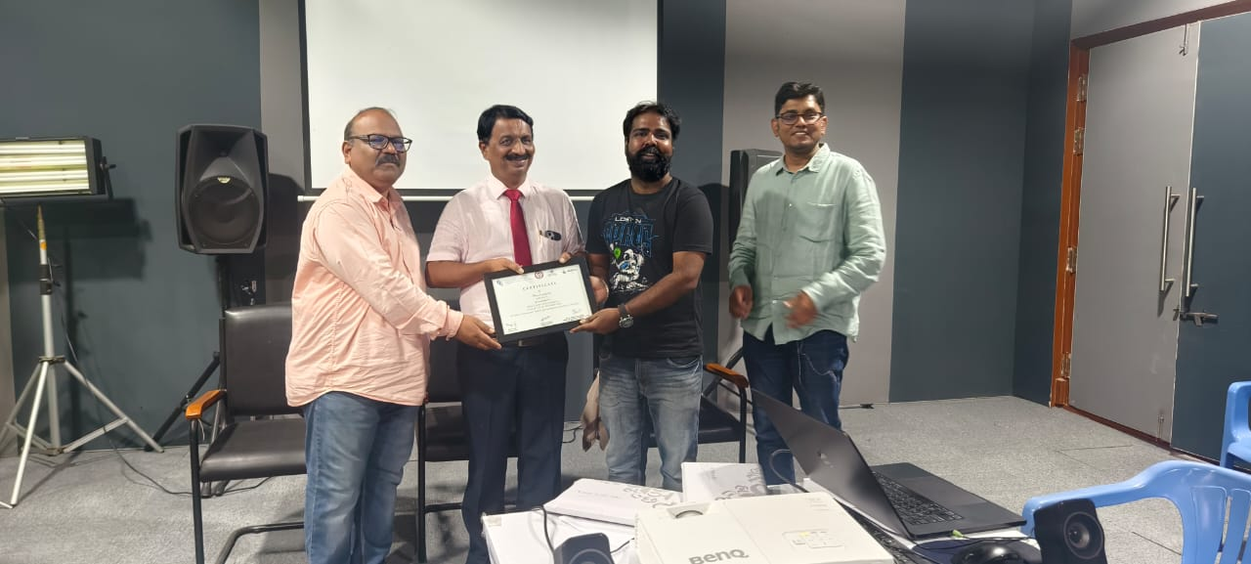
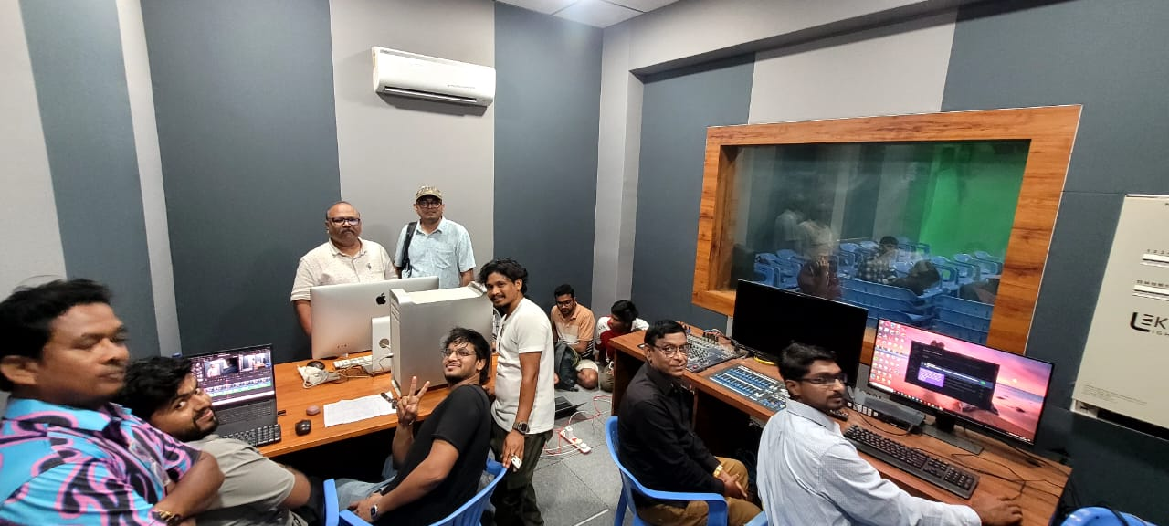
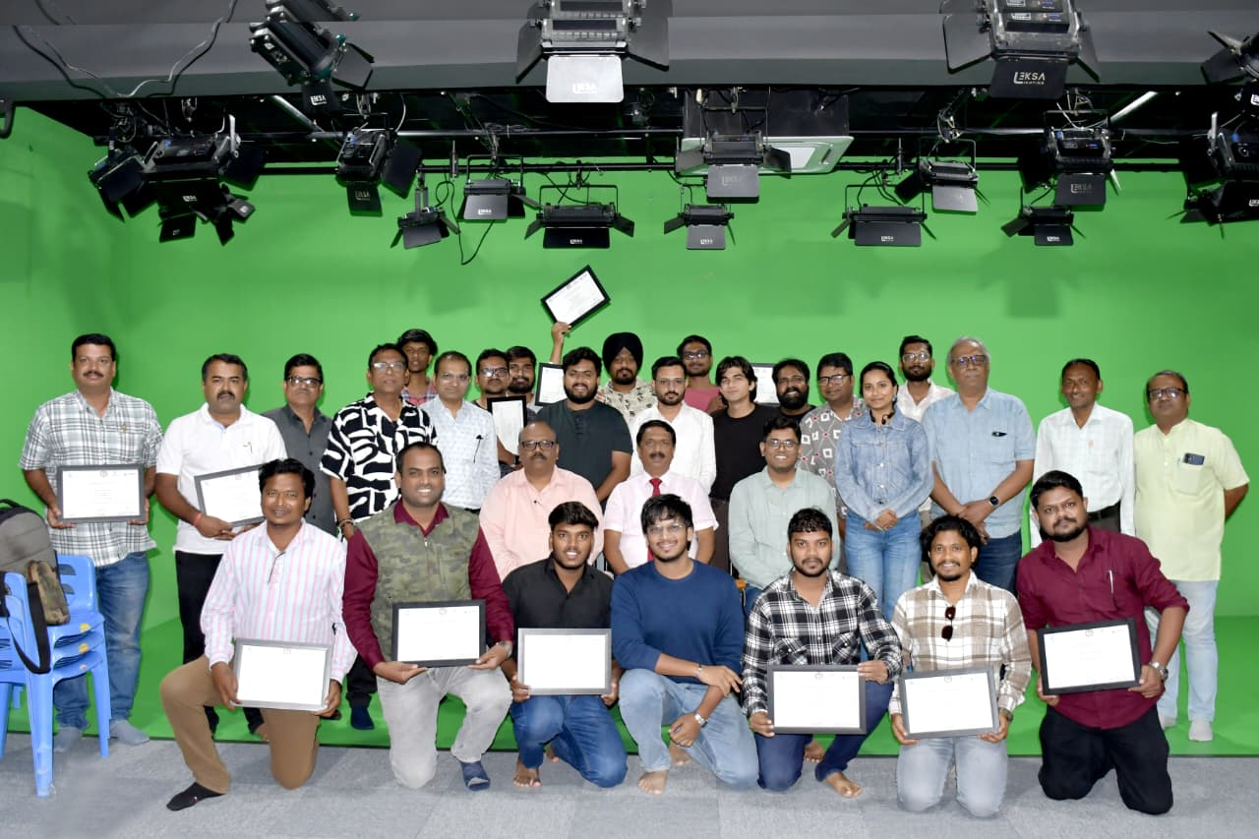
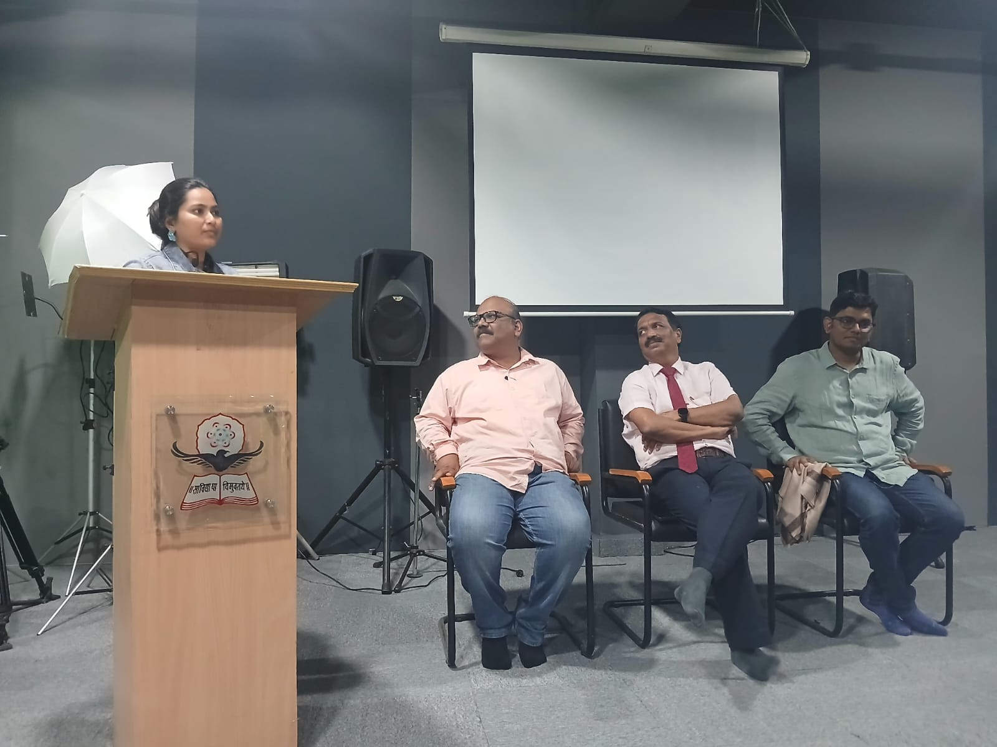
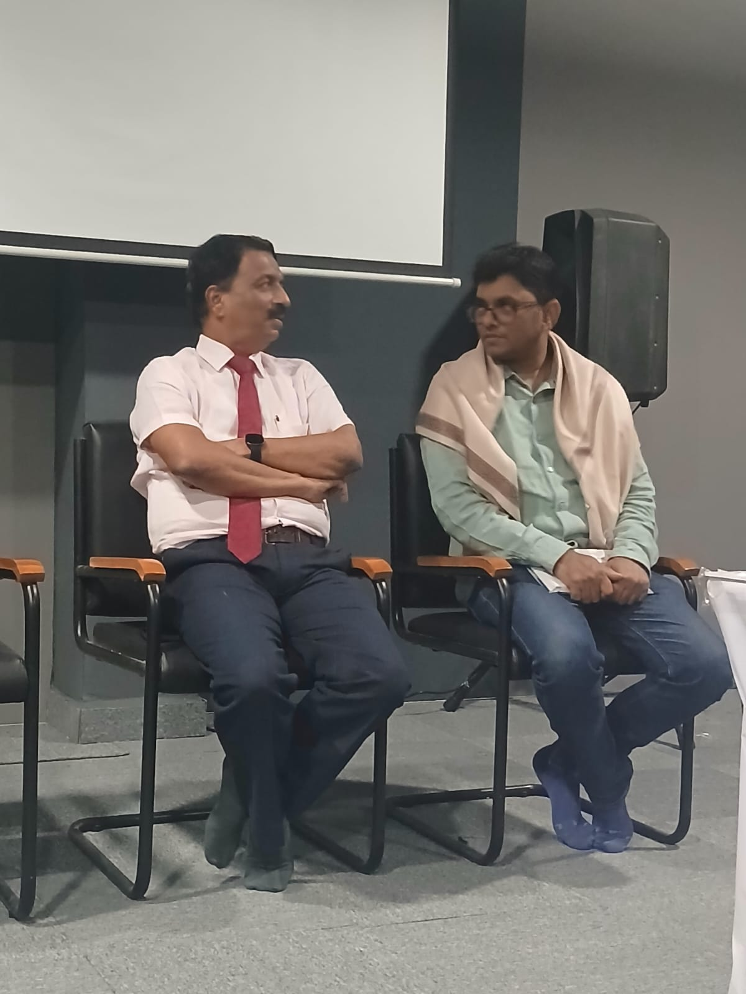
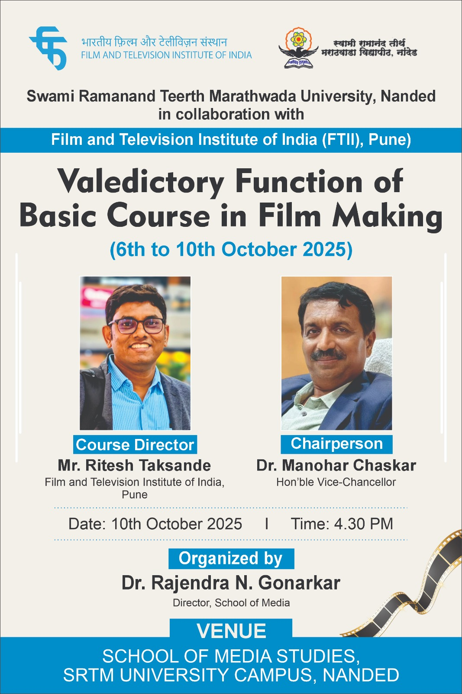

- Annexures:
  - Brochure / Circular of activity.
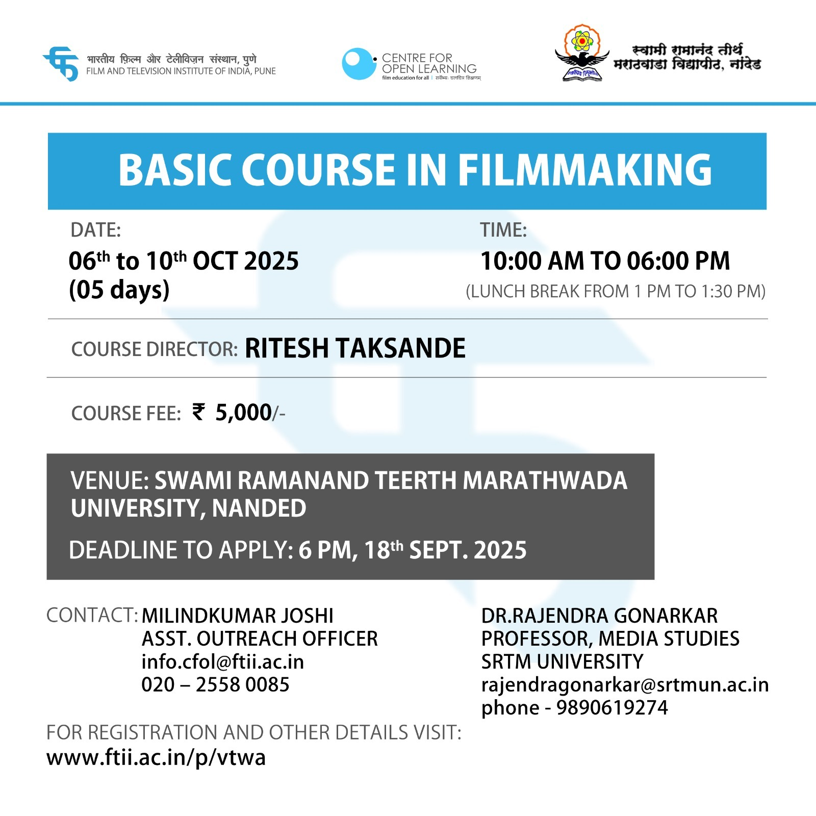

  - Minute to minute program of activity, if any
स्वामी रामानंद तीर्थ मराठवाडा विद्यापीठ, नांदेड व फिल्म अँड टेलिव्हिजन इन्स्टिट्यूट ऑफ इंडिया, पुणे
यांच्या संयुक्त विद्यमाने आयोजित Basics of Film Making
प्रमाणपत्र वितरण व समारोप सोहळा
अध्यक्ष :
मा. डॉ. मनोहर चासकर,कुलगुरू
प्रमुख उपस्थिती :
रितेश ताकसांडे, कोर्स डायरेक्टर (FTII पुणे )
दिनांक :10 ऑक्टोबर 2024
वेळ : सायंकाळी ५ वाजता
स्थळ : माध्यमशास्त्र संकुल
आपली उपस्थिती प्रार्थनीय आहे.
विनीत
डॉ. राजेंद्र गोणारकर, संचालक
  - Sample feedback form:
  - Sample certificate issued to participant
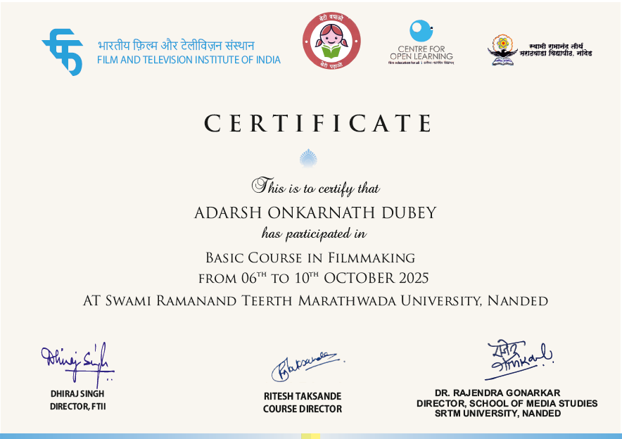

  - Copy of newspapers, news published, if any

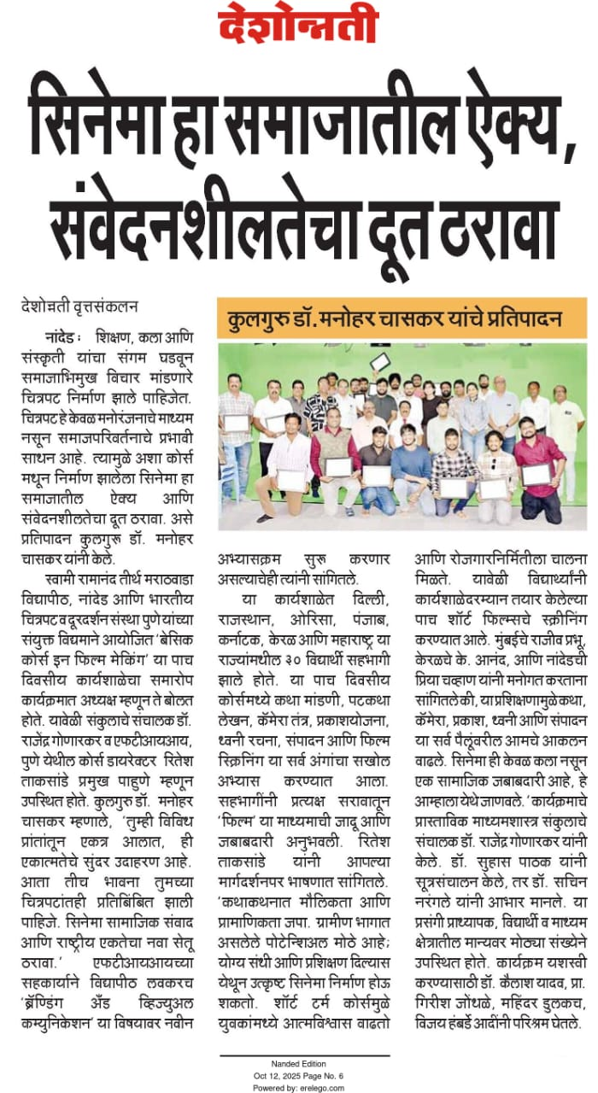
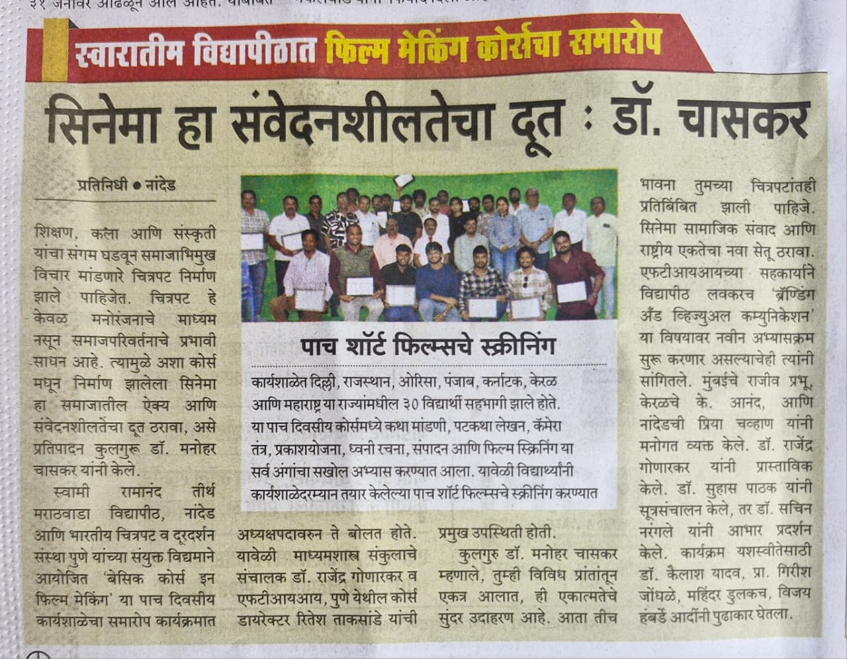
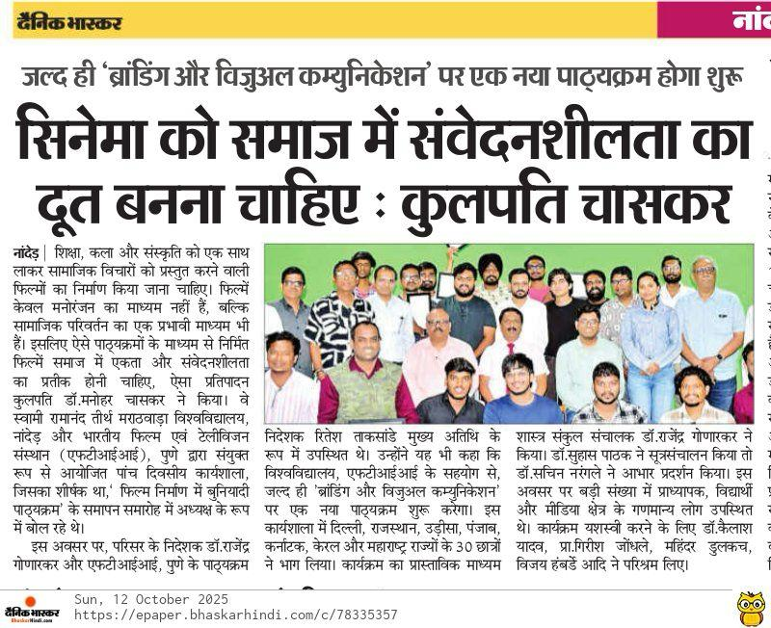
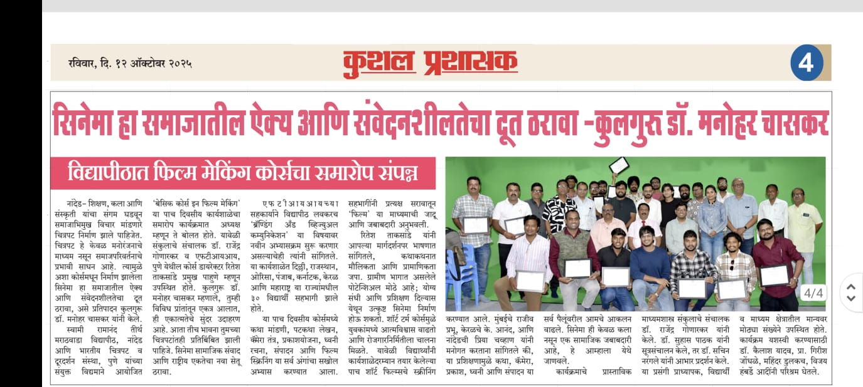
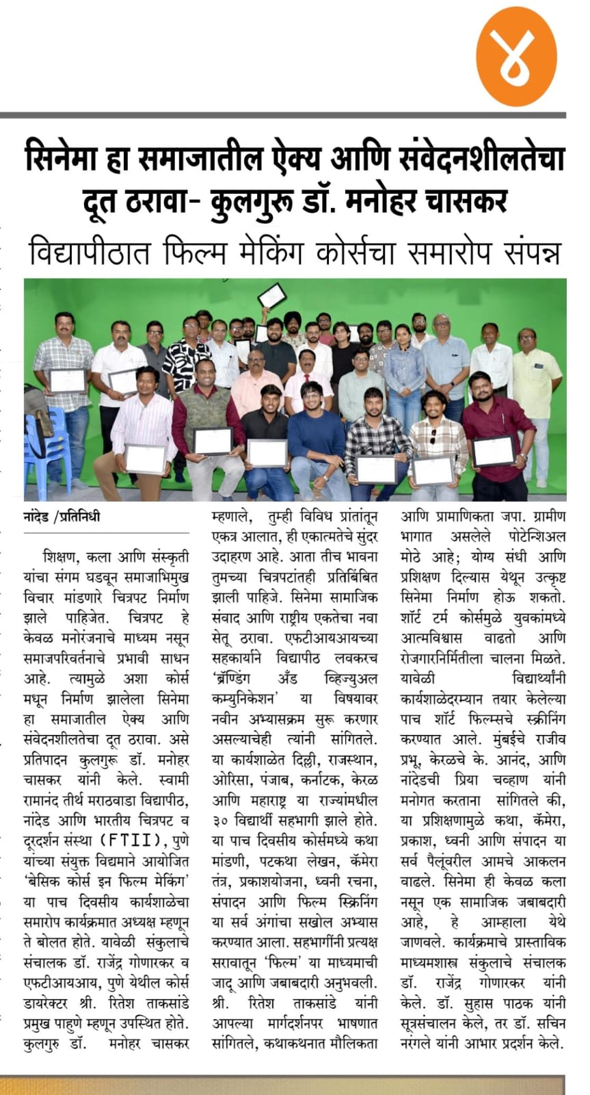
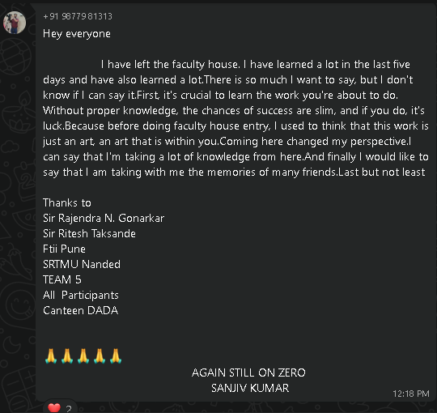

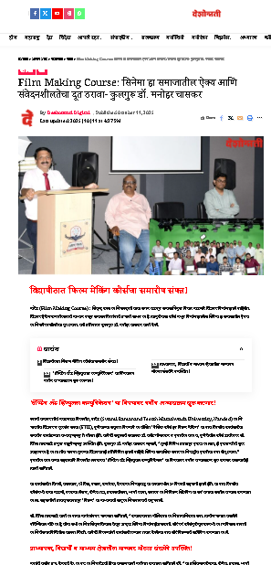

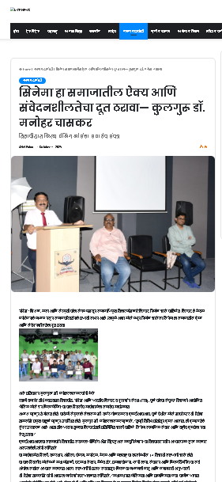

Film and Television Institute of India, Pune and
Swami Ramanand Teerth Marathwada University Nanded
Basics of Film Making
06 to 10 October 2025
List of Participants
- ADARSH ONKARNATH DUBEY
- AKSHAY RAJESHRAO SHAHANE
- AMOL CHANDRASHEKHAR SAWANT
- ANAND K.
- BISWAJIT SAHOO
- DILJOT SINGH
- DR. SAHEBRAO PURBHAJI DHAWALE
- GURA SINKU
- KAILASH BHANUDAS YADAV
- KAPIL SHESHRAO MORE
- KISHOR SHAHAJI JADHAV
- MANOHAR LAXMANRAO SONKAMBLE
- MITHILESH MAHESH DESHPANDE
- NIDHEESH P DHARAN
- PRIYA BALIRAM CHAVAN
- RAJEEV DAYANAND PRABHU
- RAJESH KUMAR PASWAN
- RAHUL DIGAMBARRAO JONDHALE
- RAMACHANDRA NIVRUTTI JADHAV
- SANJIV KUMAR
- SACHIN MANOHARRAO NARANGALE
- SEKHAR PRAKASH
- SHRIKANT SHARAD PATIL
- SURAJ RAMAJI MAHALLE
- TANAY HARIHAR DHUTMAL
- VIKAS RANA
- VINAY KUMAR A.

Chief Organiser:
Dr. Rajendra N. Gonarkar
Professor and Director
School of Media Studies,
SRTMU, Nanded

.

