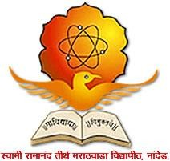

Swami Ramanand Teerth Marathwada University, Nanded- 431606
Internal Quality Assurance Cell (IQAC)
Activity Report

Name of the School / Section: School of Media Studies, SRTM University, Nanded
Activity title:
SWAMI RAMANAND TEERTH MARATHWADA UNIVERSITY, NANDED
SCHOOL OF MEDIA STUDIES
Organizes special lecture on topic
“Role of Artificial Intelligence in Media Research”
27th February 2026
Date: 27th February 2026.
Main Theme: “Role of Artificial Intelligence in Media Research”

- Objective of the activity:
School of Media Studies is a research center of Interdisciplinary Studies for subjects Mass Communication and Journalism and Information Science. The objective of this special lecture was to explore the features of Artificial Intelligence in media research.
Healthy discussions and question answers were taken place.

- Beneficiaries of the activity:
- Research scholars and academicians of subjects Mass Communication and Journalism and Information Science.
- Students of Post-Graduation of MAMCJ and MA/MSC Electronic Media.
- Academicians of subjects Mass Communication and Journalism and Information Science.

- Numbers of participants: 30
- Registration Fees Collected from Participants: NIL
- Details of experts invited for activity:

Dr. Dharmesh Dhavankar,  Head of the Department,  Mass Communication and Journalism,  Rashtrasant Tukdoji Maharaj University, Nagpur. | Dr. Sudhir Ingale  Shivaji College, Parbhani

- Brief summary of how the activity was conducted:
Date | Session Details
11 March 2024 | Inauguration 11:30 to 12:00
11 March 2024 | SESSION I  12:00 to 12:15 | Resource Person/ Chairperson:  Dr. Sudhir Ingale  Shivaji College, Parbhani
11 March 2024 | SESSION II  12:15 to 02:15 | Resource Person/ Chairperson:  Dr. Dharmesh Dhavankar,  Head of the Department,  Mass Communication and Journalism,  Rashtrasant Tukdoji Maharaj University, Nagpur.
11 March 2024 | Valedictory 02:15 to 02:30

- Outcome of activity: Session on role of Artificial Intelligence in Media research was conducted. Students and researchers were benefitted. Discussion and question answer session cleared doubts of students.

- Photo gallery (with captions)
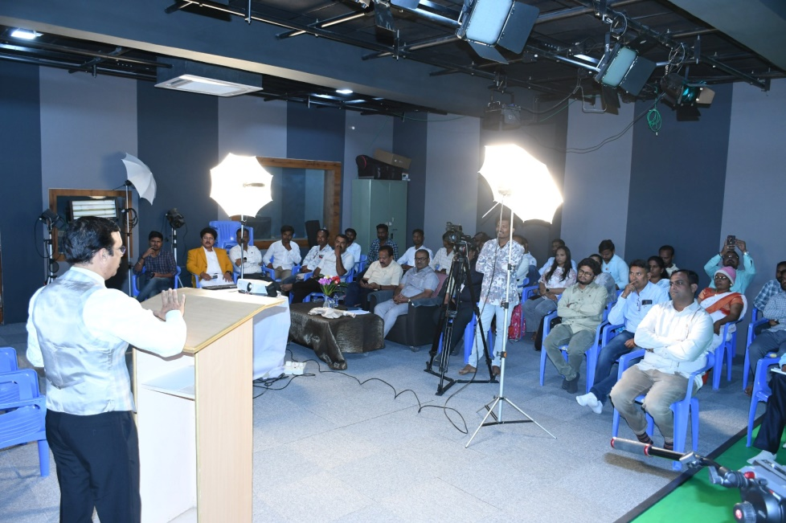
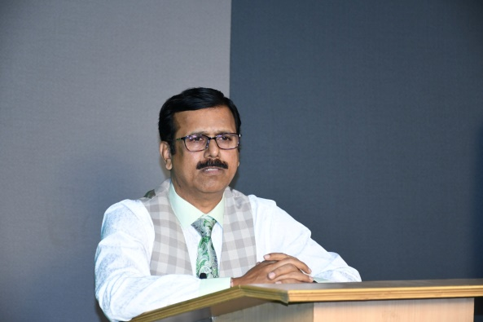 | 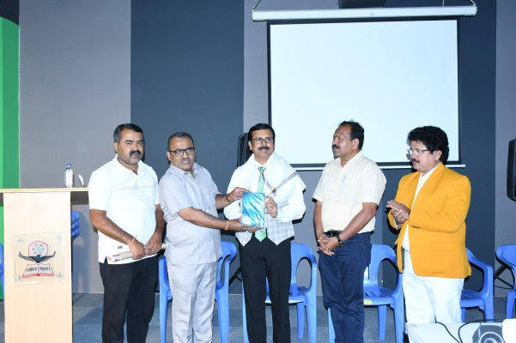
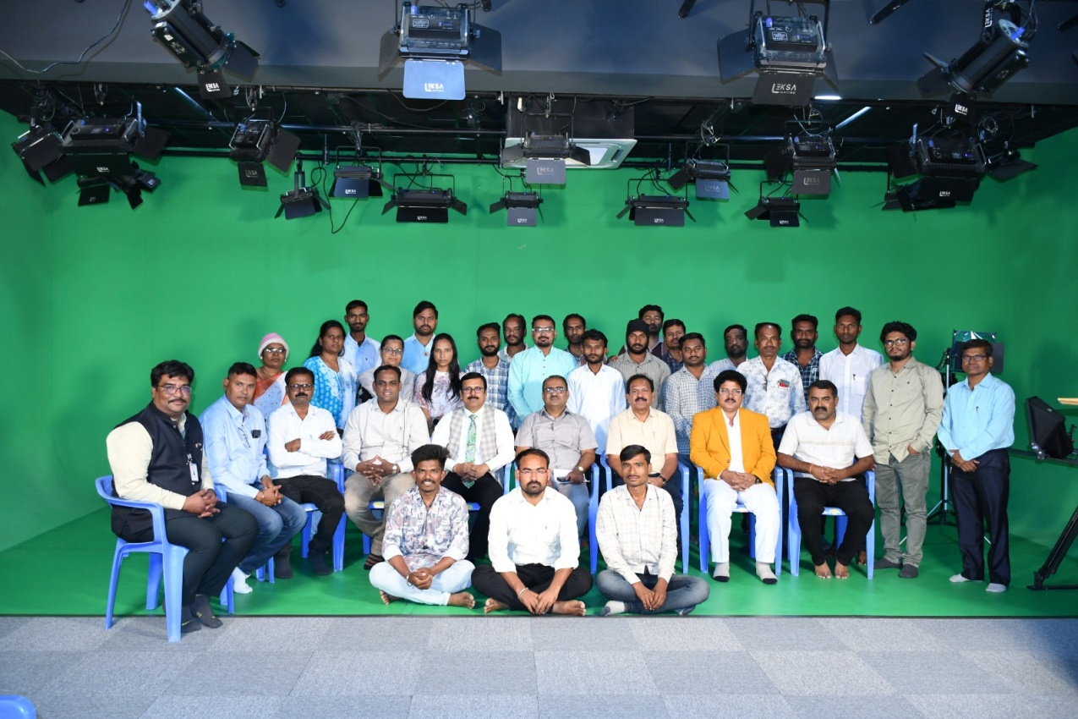

Delegates and Participants

- Annexures:
  - Brochure / Circular of activity.
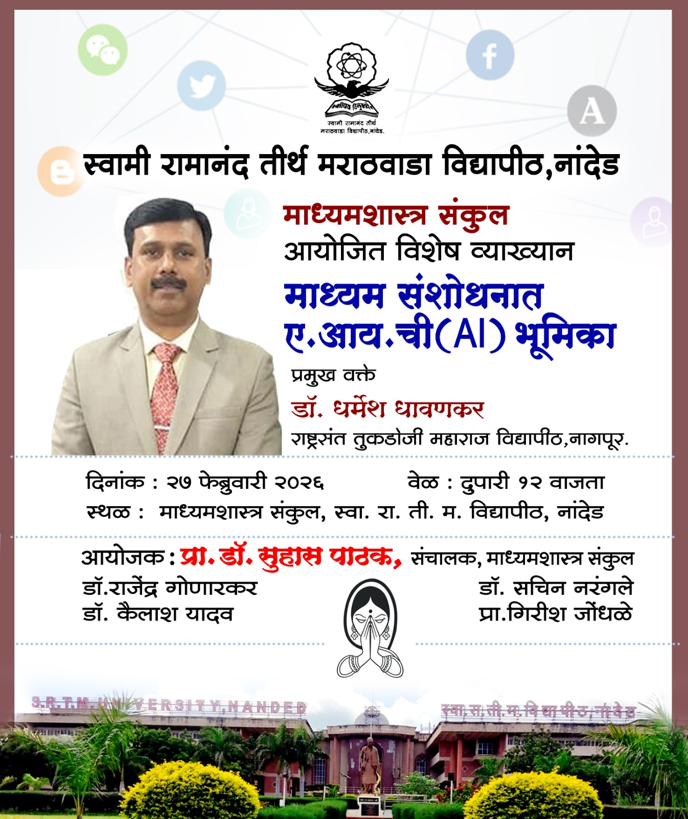

  - Minute to minute program of activity, if any
  - Sample feedback form: NIL
  - Sample certificate issued to participants: NIL
  - Copy of newspapers, news published, if any
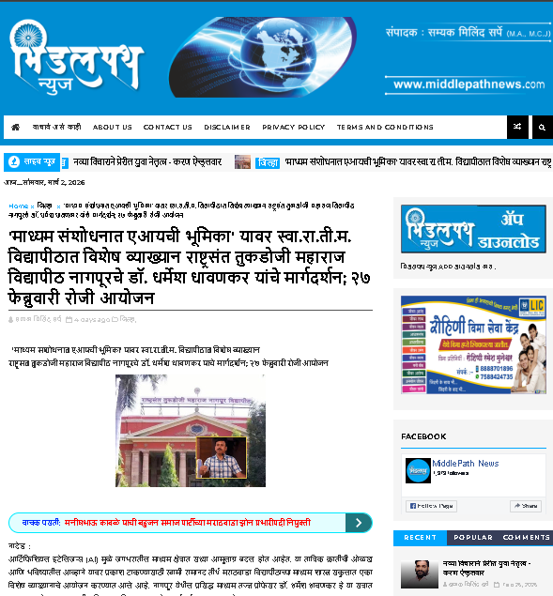
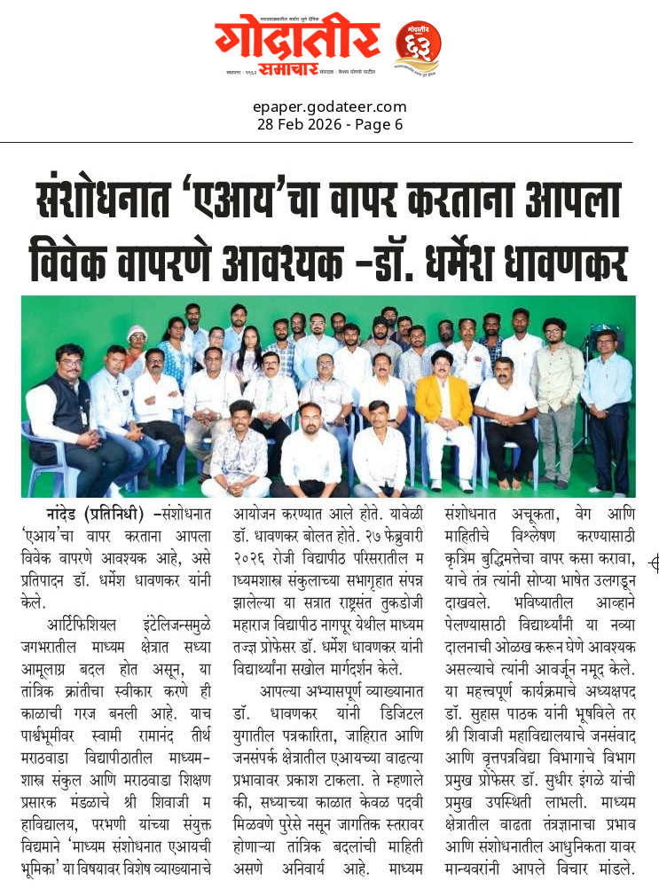
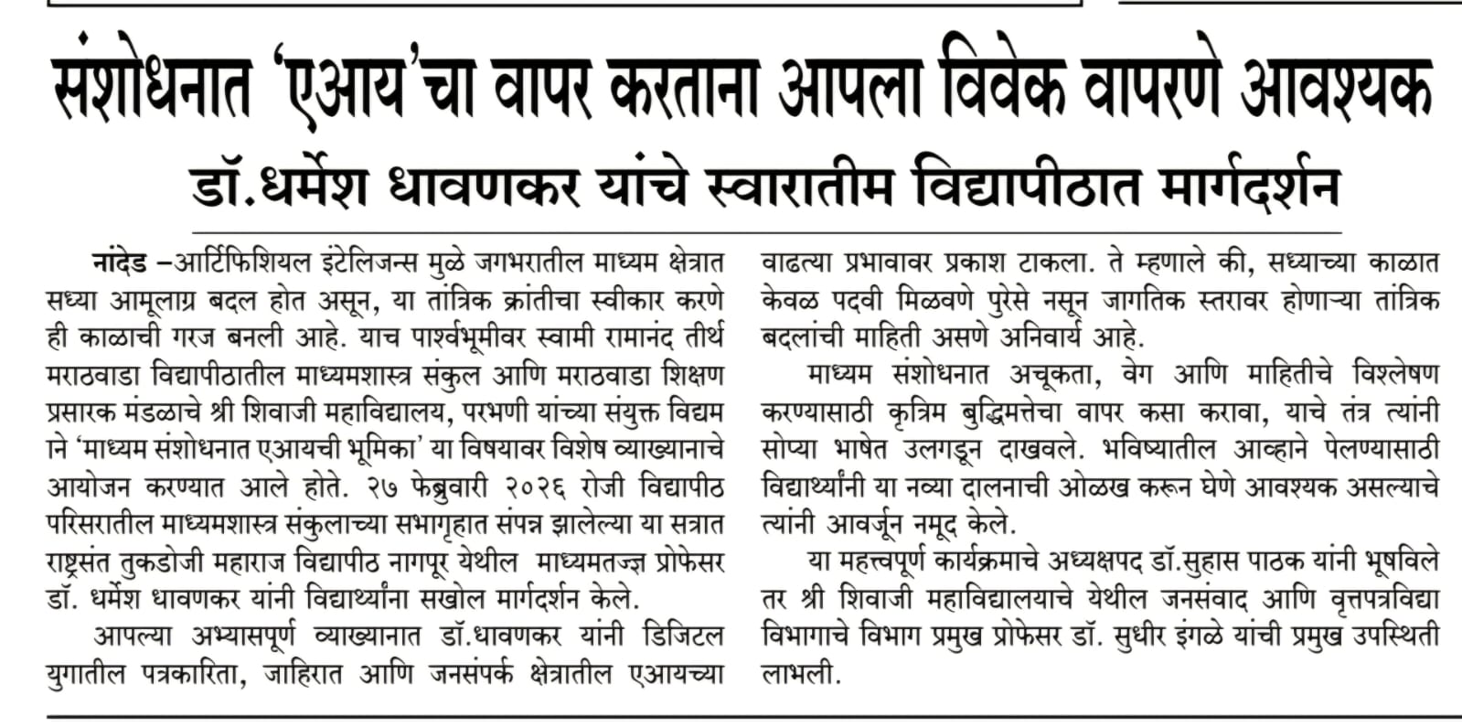

Chief Organiser:
Dr. Suhas D. Pathak
Professor and Director
School of Media Studies,
SRTMU, Nanded

