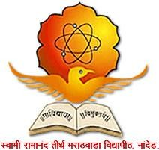

Swami Ramanand Teerth Marathwada University, Nanded- 431606
Activity Report

Activity title: School Connect – Visit of schools to SWAMI RAMANAND TEERTH MARATHWADA UNIVERSITY, NANDED

- Objective of the activity: To create awareness about SRTM University education, facilities, research, opportunities, scope amongst the school students.

- Beneficiaries of the activity:
- School students of class VI, VII, VIII, IX, X, XI and XII
- Staff members of various schools from Nanded, Latur, Parbhani, Hingoli

- Numbers of students visited SRTMU Campus and schools (2022-2024): 1800+

- Brief summary of how the activity was conducted:

Students of class VI to XII have come to visit the SRTM University campus, different schools to understand current developments in the fields of academics and research.

The students’ visit was coordinated by the faculty, staff of SRTM University. Students visited to various schools and departments like:
- School of Pharmacy
- School of Life Sciences
- School of Physical Sciences
- School of Chemical Sciences
- School of Earth Sciences
- School of Mathematical Sciences
- School of Media Studies
- School of Fine and Performing Arts
- School of Educational Sciences
- Knowledge Resource Centre
- Indoor Sports Hall
- Administrative Building

Directors and faculty members of various school interacted with students and staff. Healthy interaction and doubt answering sessions were arranged. Practical demonstration of equipment has been shown wherever possible.

- Photo gallery (with captions)
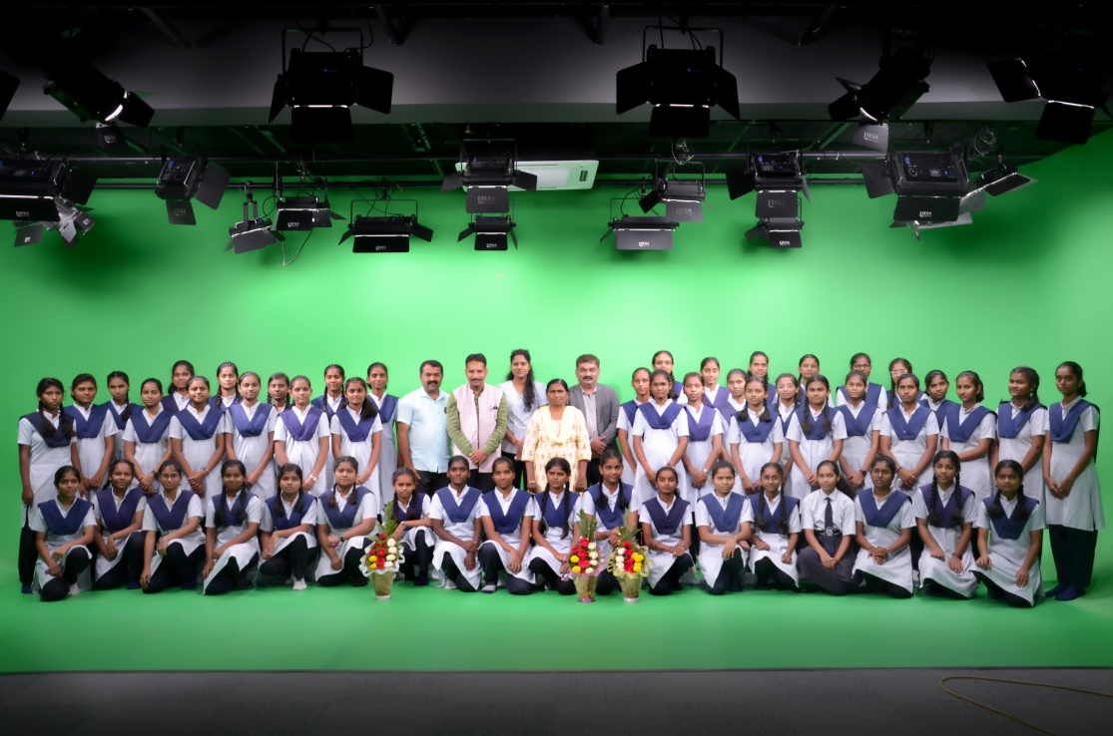
Girl students of Jawahar Navodaya Vidyalaya, Parbhani visited Multimedia Laboratory (Media Studio)
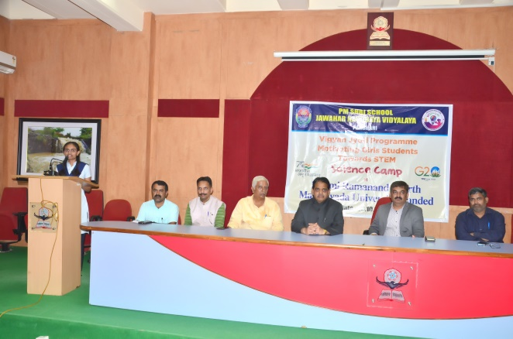 | 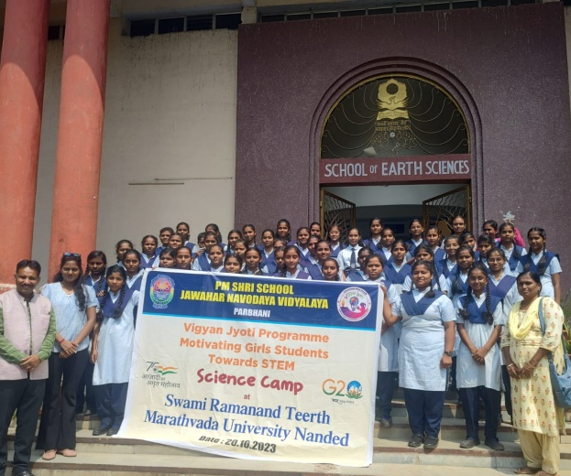
One girl representative student expressing her views about the visit | Girl students of Jawahar Navodaya Vidyalaya, Parbhani visited School of Earth Sciences
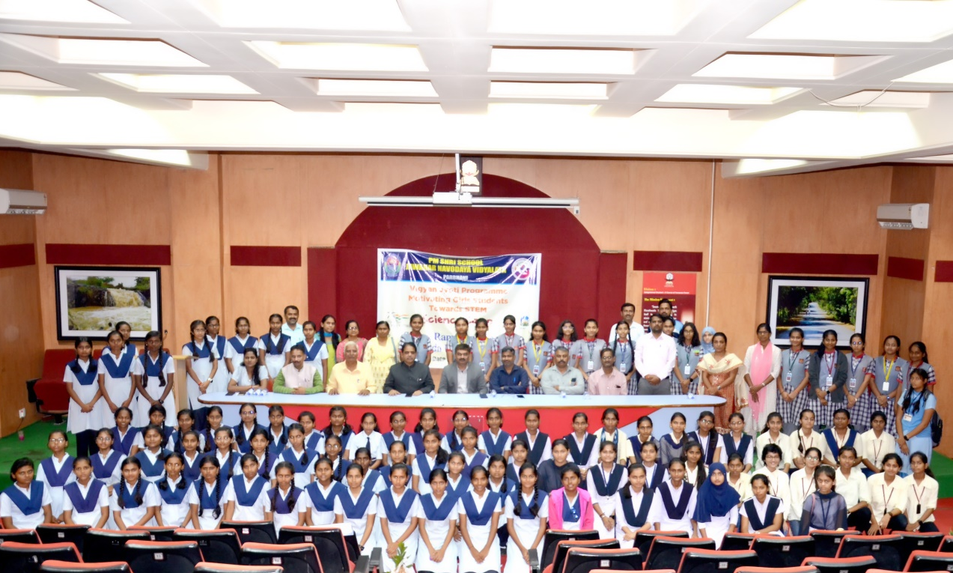
Girl students of Jawahar Navodaya Vidyalaya, Parbhani with
Hon’ble Pro-Vice Chancellor Prof. Dr. Jogendrasingh Bisen
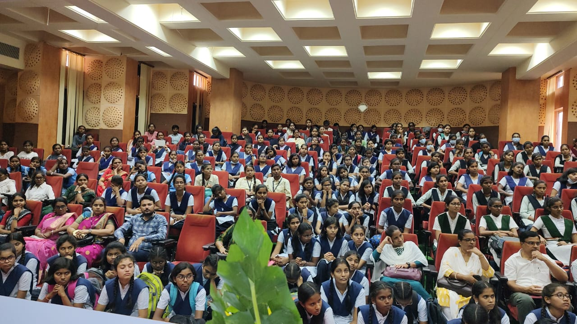
Students and faculty members having interaction with SRTM University officials.
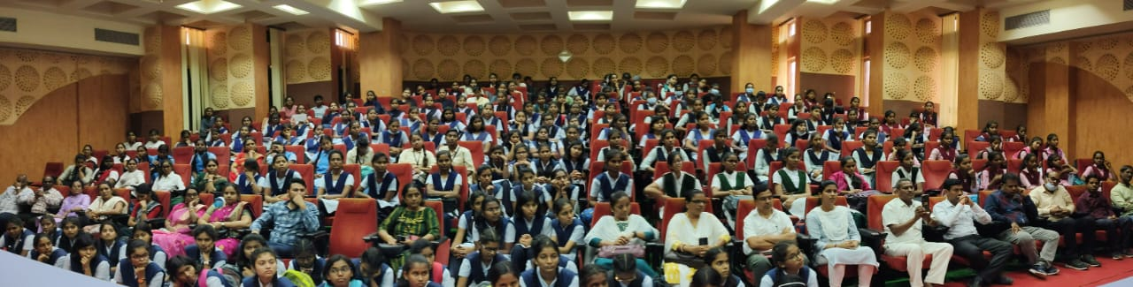
Students and faculty members having interaction with SRTM University officials.
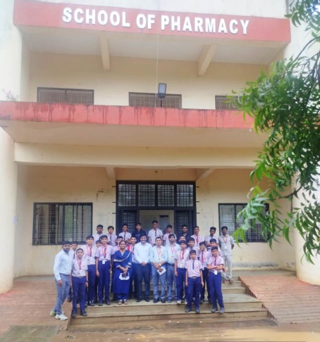 | 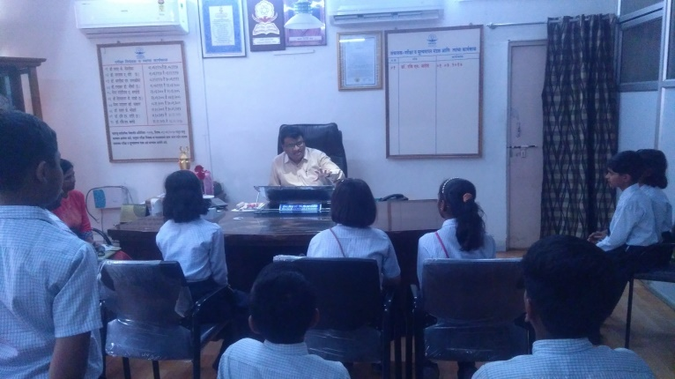
Visit of students to School of Pharmacy | Students interactions with Dr. R. N. Sarode, CoE
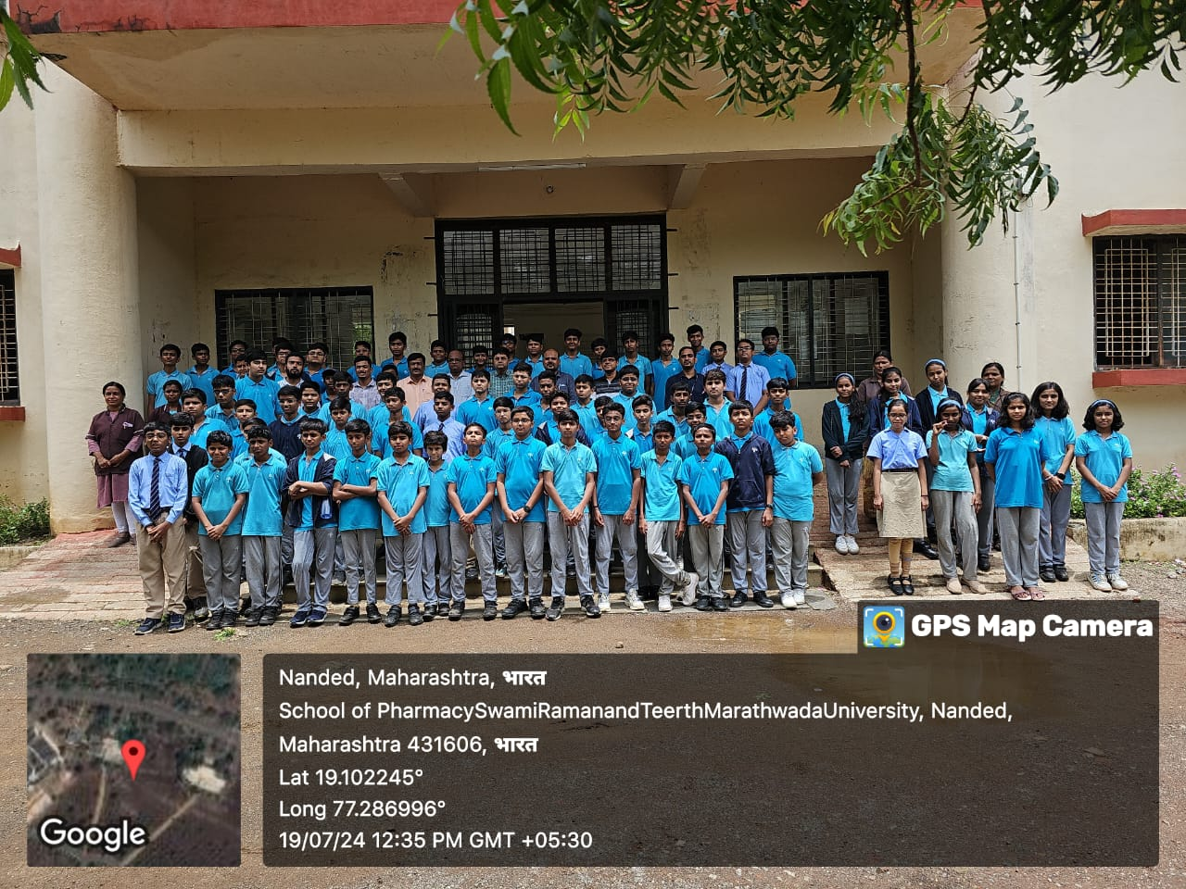
Visit of students to School of Pharmacy
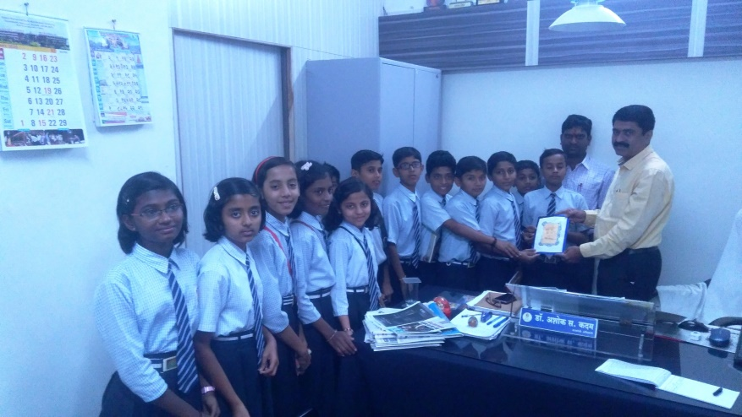
Students visit to PRO office.
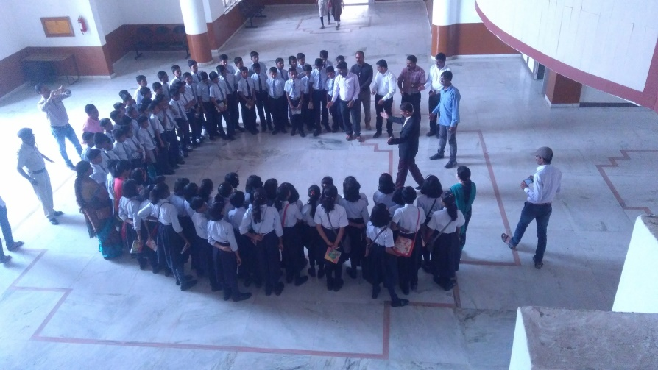
Intellectual interaction of Prof. Rajaram Mane Sir with students.
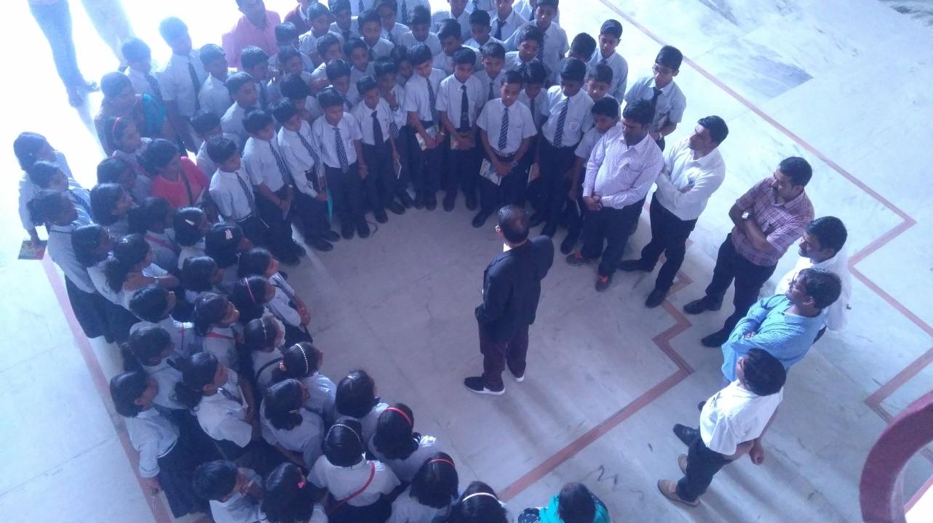
Intellectual interaction of Prof. Rajaram Mane Sir with students.
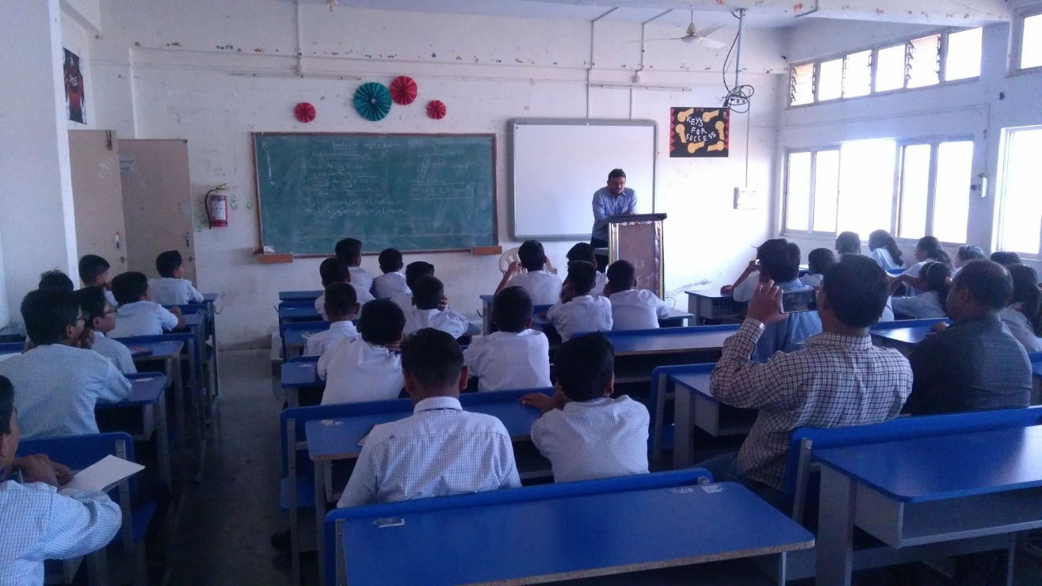
Students interaction with SRTM University faculty.
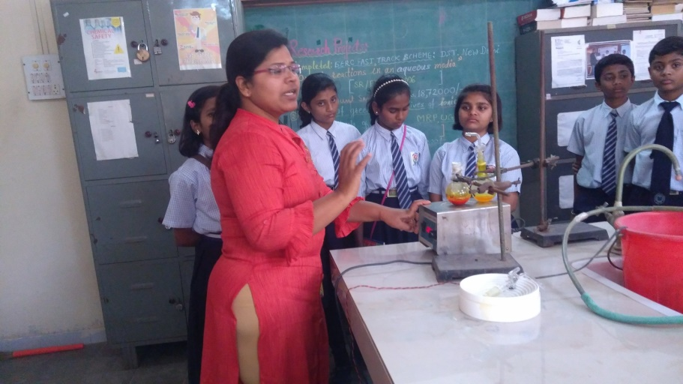
Students visit to Chemical Laboratory
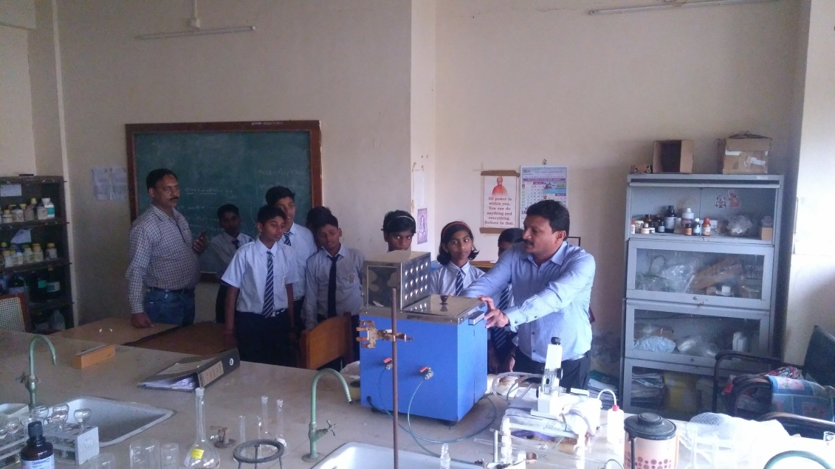
Students visit to Chemical Laboratory
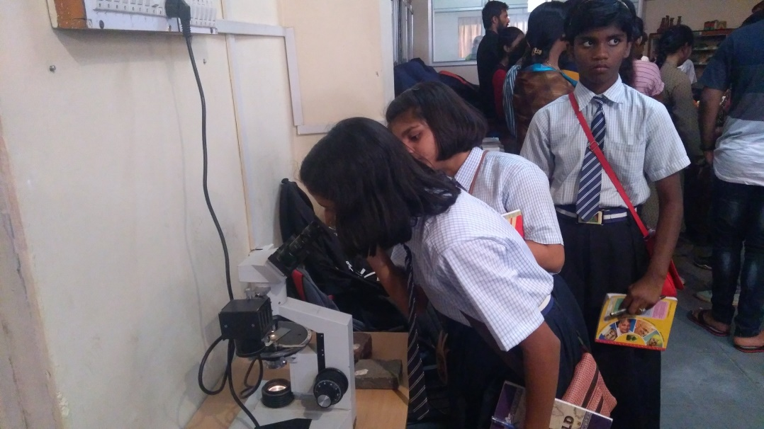
Students observing through Microscope.

- School and student count
S.N. | Name of the School/ College | Date Visited | Class | Number of Students
1 | Rajaram Kakani Sahakar Vidya Mandir and Junior College, Dharmabad | 27th July 2024 |  | 130
2 | Podar International School, Nanded | 18th July 2024 | VII | 240
3 | Podar International School, Nanded | 19th July 2024 | VIII | 220
4 | Podar International School, Nanded | 24th July 2024 | IX | 216
5 | Podar International School, Nanded | 25th July 2024 | X | 158
6 | Jawahar Navodaya Vidyalaya, Parbhani | 26th December 2023 | VI, VII, VIII, IX | 200
7 | Jawahar Navodaya Vidyalaya, Parbhani | 20th October 2023 | X, XI, XII | 200
8 | Jawahar Navodaya Vidyalaya, Shankarnagar, Nanded | 15th September 2023 | VII,IX,X | 150
9 | Jawahar Navodaya Vidyalaya, Latur | 26th December 2022 | XI, XII | 55
10 | Jawahar Navodaya Vidyalaya, Latur | 15th December 2023 | X, XII | 55
11 | Mastermind School Udgeer | 28th December 2023 | I to X | 70
12 | Kasturba Gandhi Balika Vidyalaya, Selu, Parbhani | 5th February 2024 | I to X | 115

